Anti-theft system for vending machine

**Author: Nguyễn Cao Huy Hoàng – HE153231**

**Nguyễn Tấn Việt – HE153763**

Anxious with naughty and reckless thieves making your vending machine empty in the blink of an eye by just a hammer? Let this anti-theft system stop them for you! This system’s working depends on an ultrasonic range finder called SRF05. It can detect the distance of the closest object in front of the sensor from 3 cm up to 400 cm, but for the purpose of anti-theft, we restrict the range down to 5 cm so that the ultrasonic can trigger the alerting LED to shine and the alarm whistle to make some noises. Simultaneously, the LCD display will change its status from allowing inputting to displaying the warning of distance between the locker and customer, then they will know how far they need to recede in order not to trigger the alerting LED and alarm whistle. The LCD display also restrict inputted number down to three, which prevent invalid inputs.

Hardware Required

* Arduino Board.
* Ultrasonic Range Finder SRF05.
* Hook-up wires.
* LED.
* Potentionmeter B5K.
* LCD display.
* IR Remote.
* IR Remote Control.
* Whistle Detector.

Circuit

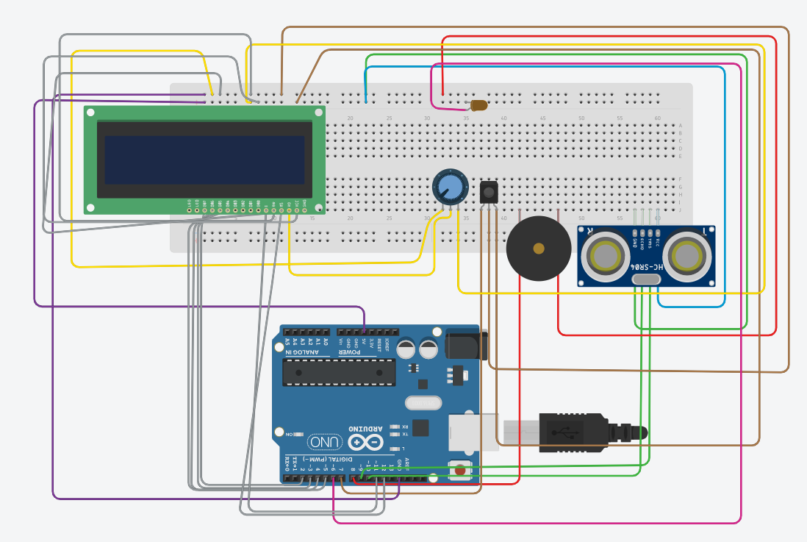

Code

// include the library code:

#include <LiquidCrystal.h>

#include <IRremote.h>

#include <stdbool.h>

// initialize the library by associating any needed LCD interface pin

// with the arduino pin number it is connected to

const int RECV_PIN = 7;

float sinVal;

int toneVal;

IRrecv irrecv(RECV_PIN);

decode_results results;

const int rs = 12, en = 11, d4 = 5, d5 = 4, d6 = 3, d7 = 2;

LiquidCrystal lcd(rs, en, d4, d5, d6, d7);

unsigned long key_value = 0;

const unsigned int TRIG_PIN = 9;

const unsigned int ECHO_PIN = 10;

const unsigned int BAUD_RATE = 9600;

#define NOTE_B0 31

#define NOTE_C1 33

#define NOTE_CS1 35

#define NOTE_D1 37

#define NOTE_DS1 39

#define NOTE_E1 41

#define NOTE_F1 44

#define NOTE_FS1 46

#define NOTE_G1 49

#define NOTE_GS1 52

#define NOTE_A1 55

#define NOTE_AS1 58

#define NOTE_B1 62

#define NOTE_C2 65

#define NOTE_CS2 69

#define NOTE_D2 73

#define NOTE_DS2 78

#define NOTE_E2 82

#define NOTE_F2 87

#define NOTE_FS2 93

#define NOTE_G2 98

#define NOTE_GS2 104

#define NOTE_A2 110

#define NOTE_AS2 117

#define NOTE_B2 123

#define NOTE_C3 131

#define NOTE_CS3 139

#define NOTE_D3 147

#define NOTE_DS3 156

#define NOTE_E3 165

#define NOTE_F3 175

#define NOTE_FS3 185

#define NOTE_G3 196

#define NOTE_GS3 208

#define NOTE_A3 220

#define NOTE_AS3 233

#define NOTE_B3 247

#define NOTE_C4 262

#define NOTE_CS4 277

#define NOTE_D4 294

#define NOTE_DS4 311

#define NOTE_E4 330

#define NOTE_F4 349

#define NOTE_FS4 370

#define NOTE_G4 392

#define NOTE_GS4 415

#define NOTE_A4 440

#define NOTE_AS4 466

#define NOTE_B4 494

#define NOTE_C5 523

#define NOTE_CS5 554

#define NOTE_D5 587

#define NOTE_DS5 622

#define NOTE_E5 659

#define NOTE_F5 698

#define NOTE_FS5 740

#define NOTE_G5 784

#define NOTE_GS5 831

#define NOTE_A5 880

#define NOTE_AS5 932

#define NOTE_B5 988

#define NOTE_C6 1047

#define NOTE_CS6 1109

#define NOTE_D6 1175

#define NOTE_DS6 1245

#define NOTE_E6 1319

#define NOTE_F6 1397

#define NOTE_FS6 1480

#define NOTE_G6 1568

#define NOTE_GS6 1661

#define NOTE_A6 1760

#define NOTE_AS6 1865

#define NOTE_B6 1976

#define NOTE_C7 2093

#define NOTE_CS7 2217

#define NOTE_D7 2349

#define NOTE_DS7 2489

#define NOTE_E7 2637

#define NOTE_F7 2794

#define NOTE_FS7 2960

#define NOTE_G7 3136

#define NOTE_GS7 3322

#define NOTE_A7 3520

#define NOTE_AS7 3729

#define NOTE_B7 3951

#define NOTE_C8 4186

#define NOTE_CS8 4435

#define NOTE_D8 4699

#define NOTE_DS8 4978

void setup() {

// set up the LCD's number of columns and rows:

lcd.begin(16, 2);

Serial.begin(9600);

irrecv.enableIRIn();

irrecv.blink13(true);

pinMode(TRIG_PIN, OUTPUT);

pinMode(ECHO_PIN, INPUT);

pinMode(8, OUTPUT);

pinMode(6, OUTPUT);

lcd.cursor();

}

void print_input_digit(int value, int count)

{

lcd.setCursor(count - 1, 0);

lcd.print(value);

}

int input_number(String command)

{

int num[2] = {0, 0};

int count, number, value;

while(true)

{

alert();

count = 11, number = 0, value = -1;

lcd.clear();

lcd.setCursor(0, 0);

lcd.print(command);

//Input number

while(true)

{

if(alert()){

lcd.setCursor(0, 0);

lcd.print(command);

num[0]=0;

num[1]=0;

count=11;

number=0;

};

if(irrecv.decode(&results))

{

Serial.println(results.value, HEX);

if(results.value == 0xFF6897) //0

{

value = 0;

++count;

if(count-11 <= 2)

{

print_input_digit(value, count);

num[count-11 - 1] = value;

}

}

else if(results.value == 0xFF30CF) //1

{

value = 1;

++count;

if(count-11 <= 2)

{

print_input_digit(value, count);

num[count -11- 1] = value;

}

}

else if(results.value == 0xFF18E7) //2

{

value = 2;

++count;

if(count-11 <= 2)

{

print_input_digit(value, count);

num[count -11- 1] = value;

}

}

else if(results.value == 0xFF7A85) //3

{

value = 3;

++count;

if(count-11 <= 2)

{

print_input_digit(value, count);

num[count -11- 1] = value;

}

}

else if(results.value == 0xFF10EF) //4

{

value = 4;

++count;

if(count-11 <= 2)

{

print_input_digit(value, count);

num[count -11- 1] = value;

}

}

else if(results.value == 0xFF38C7) //5

{

value = 5;

++count;

if(count-11 <= 2)

{

print_input_digit(value, count);

num[count -11- 1] = value;

}

}

else if(results.value == 0xFF5AA5) //6

{

value = 6;

++count;

if(count-11 <= 2)

{

print_input_digit(value, count);

num[count -11- 1] = value;

}

}

else if(results.value == 0xFF42BD) //7

{

value = 7;

++count;

if(count-11 <= 2)

{

print_input_digit(value, count);

num[count -11- 1] = value;

}

}

else if(results.value == 0xFF4AB5) //8

{

value = 8;

++count;

if(count -11<= 2)

{

print_input_digit(value, count);

num[count -11- 1] = value;

}

}

else if(results.value == 0xFF52AD) //9

{

value = 9;

++count;

if(count-11 <= 2)

{

print_input_digit(value, count);

num[count -11- 1] = value;

}

}

else if(results.value == 0xFFA857) //enter

{

irrecv.resume();

lcd.clear();

break;

}

irrecv.resume();

}

}

if(count-11 == 0)

{

lcd.clear();

lcd.setCursor(0, 0);

lcd.print("No code");

delay(1000);

continue;

}

else if(count-11 >= 2)

{

number = num[0] * 10 + num[1];

}

// Serial.println(number);

//Validate the input number

break;

}

return number;

}

bool alert() {

digitalWrite(TRIG_PIN, LOW);

delayMicroseconds(2);

digitalWrite(TRIG_PIN, HIGH);

delayMicroseconds(10);

digitalWrite(TRIG_PIN, LOW);

unsigned long duration = pulseIn(ECHO_PIN, HIGH);

int distance = duration / 29 / 2;

if (duration == 0) {

lcd.println("no pulse");

lcd.clear();

return false;

}

else if (distance <= 5) {

digitalWrite(6, HIGH);

int melody[] = {

NOTE_C4, NOTE_G3, NOTE_G3, NOTE_A3, NOTE_G3, 0, NOTE_B3, NOTE_C4

};

// note durations: 4 = quarter note, 8 = eighth note, etc.:

int noteDurations[] = {

4, 8, 8, 4, 4, 4, 4, 4

};

for (int thisNote = 0; thisNote < 8; thisNote++) {

int noteDuration = 1000 / noteDurations[thisNote];

tone(8, melody[thisNote], noteDuration);

int pauseBetweenNotes = noteDuration * 1.30;

delay(pauseBetweenNotes);

// stop the tone playing:

noTone(8);

lcd.clear();

lcd.print("STAY AWAY!");

}

delay(3000);

lcd.clear();

digitalWrite(6, LOW);

return true;

}

}

void loop() {

// set the display to automatically scroll:

lcd.noAutoscroll();

alert();

int Min=0,Max=50;

int code = input_number("Enter code:");

if(code < Min || code > Max)

{

lcd.clear();

lcd.setCursor(0, 0);

lcd.print("Wrong Code!");

delay(2000);

}

else{

lcd.print("PLACE ");

lcd.print(code);

lcd.print(" SUCCESS");

delay(1000);

}

alert();

irrecv.resume();

delay(100);

}